**Paediatric Crisis Management**

# 1. Anaphylaxis 2. Massive transfusion protocol 3. ROTEM guidelines 4. Pulseless arrest 5. Pulseless arrest shockable rhythm 6. Tachycardia 7. Bradycardia 8. LA toxicity 9. Malignant Hyperthermia 10.Hyperkalemia 11.Blood transfusion reactions

|  |  |  |
| --- | --- | --- |
| **Adrenaline bolus kiv repeat Prepare adrenaline infusion** | **Initial IV adrenaline bolus (0.1mg adrenaline in 10ml NS = 10mcg/mL)**  **Moderate 1 to 2 mcg/kg**  **Life threatening 4 to 10 mcg/kg**  **Peripheral IV adrenaline infusion: dilute 1.5mg adrenaline in 50mL N/S** *Concentration: 0.1mcg/kg/min = 0.2mL/kg/hr* | |
|  | **IM adrenaline 0.01mL/kg *if no IV access* (1:1000 = 1mg/mL)**  **< 6years 0.15ml (150mcg)** | |
|  | **6-12 years** | **0.3mL (300mcg) every 5min, on lateral thigh** |
| *ANZCA Perioperative Anaphylaxis Management Guidelines* | **>12 yr or adult** | **0.5mL** |

**Paediatric Anaphylaxis (0-12yrs) Initial Management**

*v.14Nov22, doses according to KKH Emergency Medicine guidelines*

|  |  |  |  |  |  |  |
| --- | --- | --- | --- | --- | --- | --- |
| **Cardiac arrest**  **(Pulseless electrical activity PEA)** | | |  | | | **Start CPR immediately**  **10mcg/kg of IV adrenaline, repeat 1-4 min as needed**  **20ml/kg crystalloid**  **Advanced life support for non-shockable rhythms** |
| DR |  | **Danger & Diagnosis Response to Stimulus** | | | **Unresponsive hypotension or bronchospasm**  **Remove triggers eg. latex, chlorhexidine, colloid**  **Stop procedure. Use minimal volatile/ TIVA if GA** | | | |
| S |  | **Call for help**  **Organise team** | | **Call for help, press OT code blue button if needed Assign team leader and scribe** | | | |
| AB |  | **Secure airway 100% Oxygen** | | | **Check capnography, no trace = wrong place**  **Confirm FiO2 100%**  **Intubate: early airway edema** | | | |
| C |  | **Rapid fluid bolus Large volume resuscitation** | | **If hypotensive, elevate legs**  **Bolus 20ml/kg crystalloid, repeat as needed**  **Large bore IV access, warm IV fluids** | | | |
| D |

*Adapted from ANZAAG-*

# Paediatric Anaphylaxis

**Refractory Management**

**Triggers removed?**

●

Chlorhexidine, including impregnated CVCs

●

Synthetic colloid

●

Latex

**Monitoring**

●

Consider arterial line

●

Consider TTE/ TEE

|  |  |
| --- | --- |
| **Resistant Hypotension**   * Additional IV fluid bolus 20-40mL/kg * Continue adrenaline infusion * Add 2nd vasopressor * Consider CVC ● TTE / TEE | * Additional IV fluid bolus 20-40mL/kg * **Noradrenaline infusion** 0.1 to 2 mcg/kg/min   Peripheral dilution: 1.5mg noradrenaline in 50mL N/S   * **Vasopressin infusion** 0.02 to 0.06mcg/kg/hour   CVL: 1unit/kg in 50mL, 2mL bolus then 1-3mL/hour  Peripheral access max. concentration = 1unit/mL   * Glucagon 20-30mcg/kg IV to max 1mg, over 5min |
| **Resistant Bronchospasm**   * Consider   ○ Esophageal intubation  ○ Airway device/ Circuit malfunction  ○ Tension pneumothorax   * Continue adrenaline infusion * Add alternative bronchodilators | * **Salbutamol MDI** (100mcg/puff)   ≤10kg 5 puffs; >10kg 10 puffs   * Consider Ipratropium bromide MDI (in MOT ADC)   ≤10kg 2 puffs; >10kg 4 puffs   * **Magnesium sulphate 50%: 50mg/kg** dilute in 100ml NS over 20 min, max 2g per dose. (0.1mL/kg 50% solution = 1mg/kg) * **Aminophylline 5mg/kg** in 50mL N/S over 20min (max 500mg), max peripheral concentration: 2.5mg/mL * **Hydrocortisone 2-4mg/kg** (max 200mg) |

**Consider differential diagnosis**

# Paediatric Anaphylaxis

**Post Crisis Management**

|  |  |  |
| --- | --- | --- |
| **Monitoring** |  | Monitor closely for 6 hours, consider HD/ICU Anaphylaxis may persist >24h despite aggressive treatment |

**Once stabilised**

|  |  |  |
| --- | --- | --- |
| Consider Steroids |  | **IV dexamethasone 0.1-0.4mg/kg IV hydrocortisone 2-4mg/kg** |
| Consider ORAL anti-histamines |  | IV anti-histamines *not recommended* |

**Consider: Proceed / cancel surgery Postop HD or CICU monitoring**

|  |  |  |
| --- | --- | --- |
| **Investigations**  ***Tryptase, serum*** |  | **Serum tryptase** (paediatric brown top tube, 1.5mL)  1st sample ASAP during the event  2nd sample 1-2h after onset of event  3rd sample 24h after onset  **Other investigations as clinically indicated** |
| **Referral to allergist** |  | For investigation of anaphylaxis |

# Paediatric Massive Transfusion Protocol

|  |  |  |
| --- | --- | --- |
| |  | | --- | | **Cycle 1** | |  |
| |  | | --- | | **Cycle 2** | |
| |  | | --- | | **Cycle 3** | |

**Paediatric Massive Transfusion Protocol**

**Indications for MTP**

Child given > 40ml/kg fluid bolus or > 20ml/kg blood products

Due to hemorrhagic shock from uncontrolled bleeding

No severe head injury/ spinal

cord injury

Associated severe head injury/

spinal cord injury

Keep normal cerebral perfusion

pressure; CPP = MAP

-

ICP

Treat hypotension aggressively

Haemostatic resuscitation with

permissive tachycardia

**Systolic BP goals**

<1

month old

60

mmHg

1

month to 1yr 70 mmHg

1

to 10 yrs 70 + (age in yrs x 2)

>10

yrs old 90 mmHg

**Targets**

Temp >35

℃

, treat hyperthermia aggressively

Platelets > 50k if no significant head injury

>

100k if significant head injury

Blood gases: pH >7.2

BE <

-

6

Ca >1.1mmol/L

Watch for

hyperkalemia

PT/ APTT <1.5x normal, INR ≤ 1.5

Fibrinogen >1.0 g/dL

Lactate < 3 mmol/L

# Paediatric ROTEM Transfusion Algorithm

|  |  |
| --- | --- |
| **Physiological targets**: Temp>36℃ | pH >7.2 iCa >1mmol/L Hb >7g/dL |

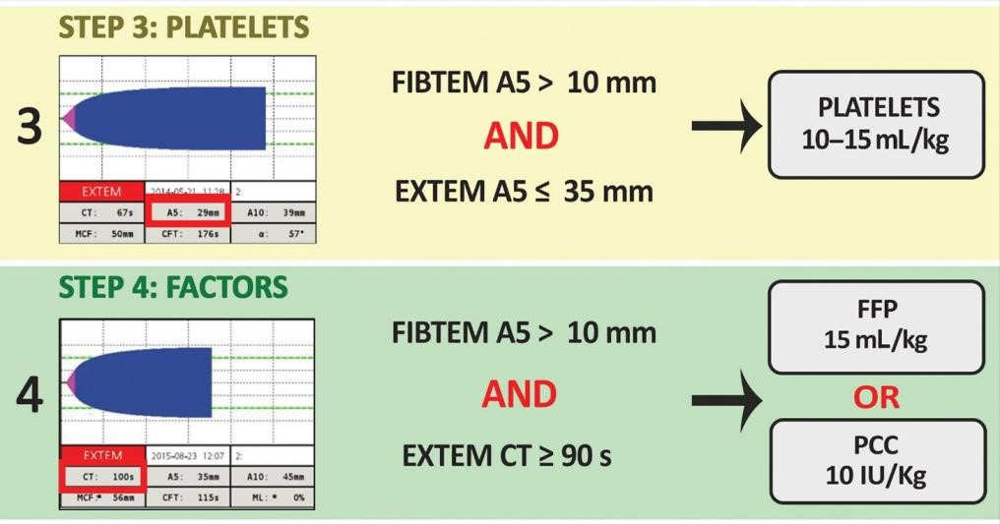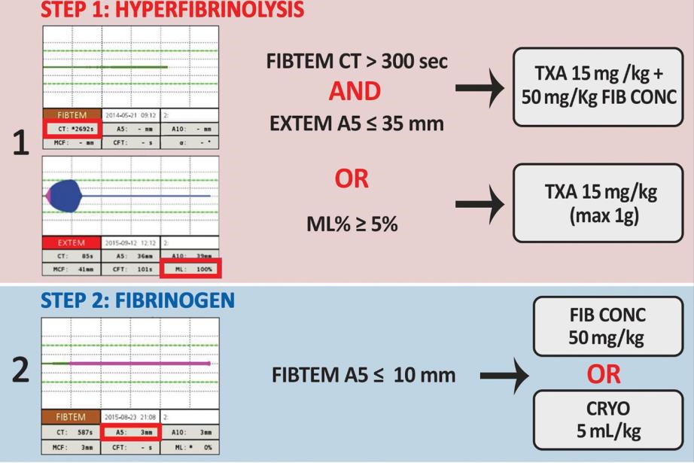

*George, S., Wake, E., Sweeny, A., Campbell, D.,Winearls, J. (2022)*

*Rotational thromboelastometry in children presenting to an Australian major trauma centre: A retrospective cohort study. Emergency Medicine Australasia, 34: 590-598*

# Suggested paediatric ROTEM reference ranges

|  |  |  |  |  |  |  |  |  |  |  |
| --- | --- | --- | --- | --- | --- | --- | --- | --- | --- | --- |
|  | **EXTEM** | | | | | **INTEM** | | |  |  |
| Age group | CT(s) | CFT (s) | Ɑ (°) | MCF (mm) | LI 30 (%) | CT(s) | CFT (s) | Ɑ (°) | MCF (mm) | ML (%) |
| **Newborns** (0-30 days) | 35-70 | 40-150 | 52-82° | 40-80 | 90-100 | 65-135 | 50-220 | 45-75° | 40-70 | 0-15 |
| **Infants** (1-12 months) | 35-70 | 30-140 | 54-76° | 45-82 | 95-100 | 60-130 | 45-200 | 48-78° | 42-76 | 0-12 |
| **Children**  (1-12 yrs) | 33-69 | 25-120 | 58-78° | 50-84 | 95-100 | 55-120 | 40-180 | 50-80° | 44-78 | 0-10 |
| **Adolescents** (12-18 yrs) | 33-69 | 20-110 | 60-74° | 55-86 | 97-100 | 50-110 | 35-160 | 52-82° | 46-80 | 0-10 |
| **Adults** | 38-79 | 34-159 | 63-83° | 50-72 | 94-100 | 100-240 | 30-110 | 70-83° | 50-72 | 0-8 |

|  |
| --- |
| **Post arrest care** |
| **A&B: Oxygenation and ventilation**  O2: Avoid hypoxia/ hyperoxaemia, keep SpO2 94-98%  CO2: Target appropriate PaCO2, avoid hypocapnia  **Circulation**  Monitor BP, set hemodynamic goals after ROSC  IV fluids and/or inotropes to maintain SBP above 5th percentile **Disability** Treat clinical seizures.  **Environment: targeted temperature management**  Monitor core temperature & treat fever. Target normothermia (36 to 37℃)  **Glucose control & electrolytes**  Avoid hypoglycemia, keep blood glucose >3.5mmol/L  Maintain electrolytes within normal ranges |

|  |
| --- |
| For paediatric patients with pre-existing invasive BP monitoring, consider diastolic BP to guide resuscitative efforts.  Infants DBP > 25mmHg  1-12 years > 30mmHg  Above 12 years > 35mmHg |

Singapore Paediatric Resuscitation Guidelines 2021

**Paediatric Pulseless arrest**

Basic life support, give 100% oxygen,

attach monitors/ defib when available

**Check pulse & rhythm →**

**Shockable?**

**YES = Pulseless VF/ VT**

**NO = Asystole/ PEA**

**\*\*Reversible contributing factors (Hs & Ts):**

Hypoxia

Trauma

Hypovolemia

Toxins

H+ ion (acidosis)

Tamponade

)

cardiac

(

Hypo/ hyperkalemia

Tension

pneumothorax

Hypothermia

Thrombosis

(

pulmonary,

Hypoglycemia

cardiac)

See pulseless

VT/ VF (below)

**Check pulse & rhythm →**

**Shockable?**

**High quality CPR with ventilation**

Obtain

**IV access**

with minimal delay

Give

**adrenaline**

asap, then q3

-

5

min

IV/IO 0.01mg/kg (0.1mL/kg 1:10,000)

**Advanced airway**

placement

Chest compressions 100

-

120

/min

Ventilation: <1yr 30/min, 1

-

12

yr: 20/min,

>12

yr:

10

-

12

/min

**Search & treat reversible causes\*\***

Pulseless

-

shockable

Pulseless

-

non

-

shockable OR

HR<60/min with

hemodynamic

compromise

**Pulse present ≥ 60/min → ROSC**

**Pulseless arrest with shockable rhythm**

**st shock**

**1**

**2**

**-**

**J/kg**

**4**

Resume

CPR

**nd shock**

**2**

**J/kg**

**4**

Resume

CPR

**rd shock**

**3**

**J/kg**

**4**

Resume

CPR

**th shock**

**4**

**J/kg**

**4**

Resume

CPR

**th shock**

**5**

**4**

**J/kg**

Resume

CPR

**th shock**

**6**

**J/kg**

**4**

Resume

CPR

**IV/ IO adrenaline**

**0.01**

**mg/kg**

(

max

3

mg), q

1

-

min or

5

every other shock

**IV/ IO adrenaline**

**mg/kg**

**0.01**

(

max

1

mg), q

3

-

5

min or

every other shock

**Perform CPR 2min,**

**check pulse & rhythm**

**→ Shockable?**

**Give adrenaline every other**

**shock q3**

**-**

**min.**

**5**

Consider other

antiarrhythmics:

**IV/ IO lignocaine 1mg/kg**

followed by

**infusion 20**

**-**

**mcg/kg/min**

**50**

(

May repeat

bolus after 15min, if delay in

starting infusion >15min)

**IV/ IO amiodarone 5mg/kg**

,

up to 3 times

**IV/ IO magnesium sulphate**

**50**

**mg/kg**

(

max 2g) for

torsades des pointes.

**Consider increasing energy**

**dose**

of shocks up to

**max 10**

**J/kg**

for refractory VF

**CPR 2min then check**

**pulse & rhythm →**

**Shockable?**

Minimise time between

compressions & shock

delivery

Monitor quality of CPR

Assess & manage for

reversible causes

-

Hs & Ts**

**\*\*Search for & treat possible causes:**

Hypoxia

Trauma

Hypovolemia

Toxins

H+ ion (acidosis)

Tamponade

)

cardiac

(

Hypo/ Hyperkalemia

Tension

pneumothorax

Hypothermia

Basic life support, give oxygen, attach

monitors/ defib when available

**Check rhythm →**

**Shockable?**

**YES = Pulseless VF/ VT**

Not shockable =

Asystole/ PEA

See asystole/

PEA algorithm

*Singapore Paediatric Resuscitation Guidelines 2021*

**IV/ IO amiodarone**

**mg/kg**

**5**

OR

**IV/ IO lignocaine**

**mg/kg**

**1**

max

(

mg) initial

100

bolus, then infusion

20

-

mcg/kg/min

50

**IV/ IO amiodarone**

**mg/kg**

**5**

max 3

(

doses) OR

**IV/ IO lignocaine if**

**not given earlier,**

**1**

**mg/kg**

(

max

100

mg) initial bolus,

then infusion 20

-

mcg/kg/min

50

Thrombosis

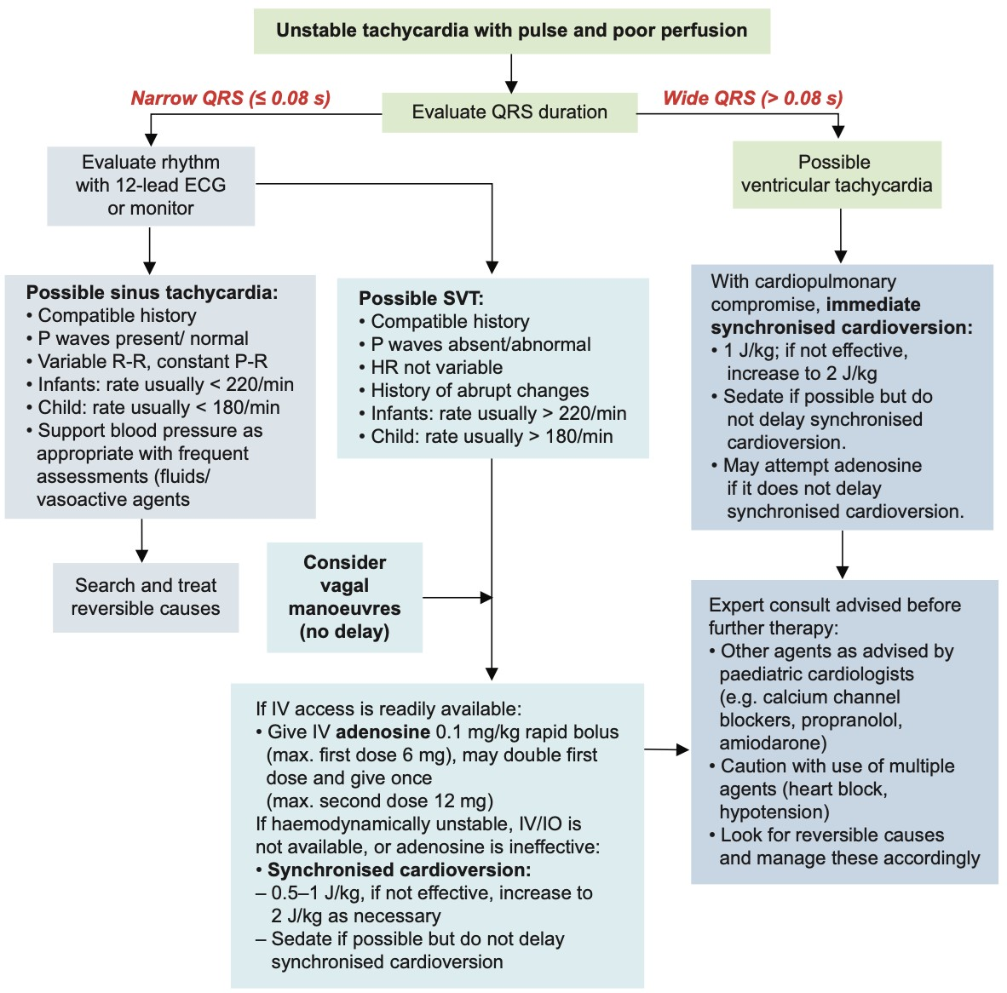**Paediatric Unstable Tachycardia**

*Singapore Paediatric Resuscitation Guidelines 2021*

# Paediatric Stable Tachycardia

*Singapore Paediatric Resuscitation Guidelines 2021*

**Paediatric**

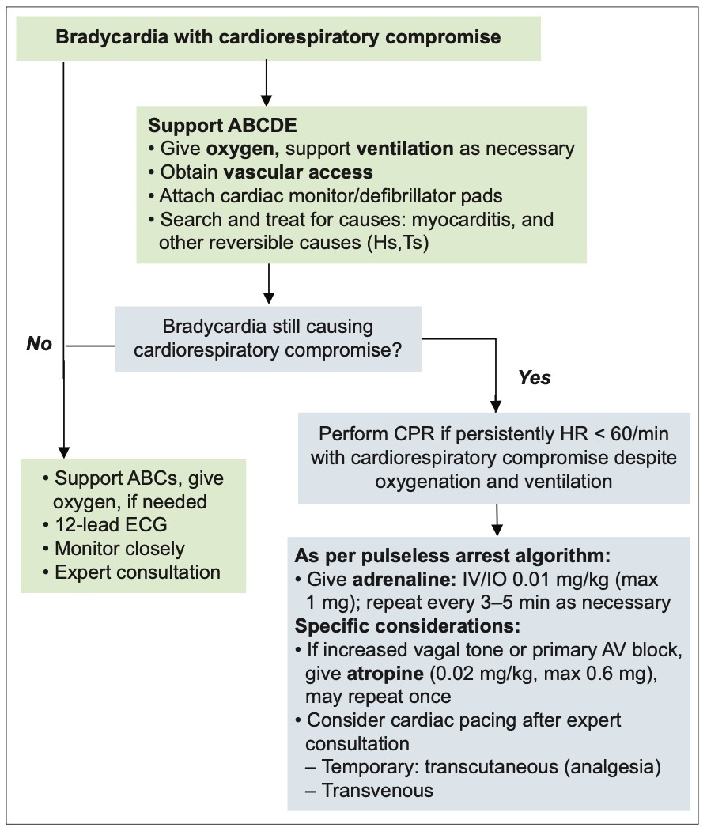**Bradycardia**

*Singapore Paediatric Resuscitation Guidelines 2021*

|  |
| --- |
| **Box A: LIPID EMULSION Regime** |
| **Use 20% SMOFlipid®** (propofol is not a suitable substitute) **Immediately:**  · Give an initial IV bolus of lipid emulsion 1.5 mL/kg over 2-3 min (~100 ml for a 70 kg adult). See drug dosing guide.  · Start an IV infusion of lipid emulsion at 15 ml/kg/h(17.5 mL/min for a 70 kg adult)  **At 5 and 10 minutes:**  · Give a repeat bolus (same dose) if: o cardiovascular stability has not been restored or  o an adequate circulation deteriorates **At any time after 5 minutes:**  · Double the rate to 30 mL/kg/h if: o cardiovascular stability has not been restored or o an adequate circulation deteriorates  **Do NOT exceed max cumulative dose 12 mL/kg(70 kg: 840 ml)** |

# Local Anaesthetic Toxicity

**1 STOP injecting the LA**, remember the infusion pumps. **2 Call for help**, inform immediate clinical team of problem **3** Call for **cardiac arrest cart**, and **LA toxicity box**.

1. Give **100% oxygen**, ensure adequate lung ventilation:

Maintain the airway and intubate if necessary

Avoid hypercarbia - consider mild hyperventilation.

1. Confirm or establish **IV access 6 If circulatory arrest**:
   * Start CPR using standard protocols but:
   * Give **IV Lipid emulsion** (see Box A)

Use **smaller adrenaline dose ≤1mcg/kg** instead of 1mg

* + Avoid vasopressin
  + Recovery may take >1 hour.

|  |
| --- |
| **Box B: CRITICAL CHANGES** |
| Cardiac arrest **→** check already done **1 to 5**, then **→ 6** |

* + Consider use of cardiopulmonary bypass if available

**If no circulatory arrest**:

|  |
| --- |
| **Box C: After the Event** |
| Arrange safe transfer to appropriate clinical area  Exclude pancreatitis: regular review, daily amylase or lipase Report as critical incident |

* + Conventional therapies to treat hypotension, brady & tachyarrhythmias.
  + Consider IV lipid emulsion (Box A)

**7 Control seizures**.

* Small incremental dose of IV midazolam 0.05-0.1mg/kg.
* Thiopentone or propofol can be used, beware negative inotropic effect
* Consider neuromuscular blockade if seizures uncontrolled. *Adapted from* ***Association of Anaesthetists 2023. www.anaesthetists.org/qrh***

|  |  |  |  |  |  |
| --- | --- | --- | --- | --- | --- |
| **Weight (kg)** | **Initial bolus 1.5ml/kg over 2-3min** | **Infusion 15ml/kg/hour** | **At 5 & 10min, give a repeat bolus if:**  **Cardiovascular stability has not**  **been restored OR**  **an adequate circulation deteriorates** | **Double infusion 30ml/kg/hour** | **Do NOT exceed max cumulative dose 12ml/kg** |
| **3** | **4.5 ml** | **ml/h** | **ml/h** | **ml** |
| **5** | **7.5 ml** | **ml/h** | **ml/h** | **ml** |
| **8** | **ml** | **ml/h** | **ml/h** | **ml** |
| **10** | **ml** | **ml/h** | **ml/h** | **ml** |
| **15** | **22.5 ml** | **ml/h** | **ml/h** | **ml** |
| **20** | **ml** | **ml/h** | **ml/h** | **ml** |
| **25** | **37.5 ml** | **ml/h** | **ml/h** | **ml** |
| **30** | **ml** | **ml/h** | **ml/h** | **ml** |
| **40** | **ml** | **ml/h** | **ml/h**  *(max rate of*  *BBraun infusion pump)* | **ml** |
| **50** | **ml** | **ml/h** | **ml** |
| **60** | **ml** | **ml/h** | **ml** |
| **70** | **ml** | **ml/h** | **ml** |

# 20% IntraLipid dosing guide

**Malignant Hyperthermia**

1. Declare Code Blue and MH Crisis, note the time.
2. Aim to abandon or finish surgery as soon as possible.
3. Call for MH box/dantrolene and cardiac arrest trolley.

|  |
| --- |
| **Box B: DANTROLENE - delegate mixing** |
| * **2-3mg/kg immediate IV bolus (adult approx 200mg)** * **Repeat 1mg/kg every 5min, until EtCO2 < 50mmHg & temp <38.5** - **Pause & observe** * **Repeat 1mg/kg to maintain EtCO2 < 50mmHg & temp <38.5, even if ‘exceeds’ maximum dose 10mg/kg** |

1. Maintain anaesthesia with TIVA..
2. *Allocate enough staff to perform* ***6*** *,* ***7*** *and* **8** *simultaneously:*
3. Eliminate trigger drug (Box A)**. Hyperventilate 15L/min 100% O2. Insert activated charcoal filters** on inspiratory & expiratory limbs of breathing circuit.
4. **Give Dantrolene (Box B).**

|  |
| --- |
| **Box A: ELIMINATE TRIGGER DRUG** |
| Turn off vaporisers & remove from anaesthesia workstation  Set fresh gas flow to 100% oxygen, 15L/min  Hyperventilate 2-3x normal minute ventilation  Place **activated charcoal filters** on both limbs of breathing circuit  Change soda lime & breathing circuit if feasible (not a priority) |

|  |
| --- |
| **DANTROLENE STOCK** |
| Located at: |

|  |
| --- |
| **Box C: ACTIVE COOLING** |
|  |
| Turn OFF active warming  Apply ICE to axillae & groins  Use cold IV fluids, consider cold peritoneal lavage  Consider surface cooling devices, intravascular devices, extracorporeal heat exchange |

1. **Begin active body cooling (Box C)**
2. Additional monitors: invasive BP, CVP, core & peripheral temp, urine output
3. Send urgent labs: ABG, U&E, glucose, FBC, PT/PTT, urinary pH, creatine kinase (peak 12-24h). Repeat as indicated.

|  |
| --- |
| **Box D: COMPLICATIONS & TREATMENTS** |
| **Metabolic acidosis**: 0.5-1mL/kg sodium bicarbonate 8.4% if pH < 7.2  **Hyperkalemia**: 0.5-1mL/kg sodium bicarbonate 8.4%, 10% Dextrose  5mL/kg with 0.1unit/kg insulin (actrapid), IV calcium gluconate 0.3mL/kg  **Myoglobinuria**: Forced alkaline diuresis, aim UOP > 2mL/kg, urine pH >7.  **DIC**: FFP, cryoprecipitate, platelets  **Tachyarrhythmias**: amiodarone, beta blockers. AVOID Ca-channel blockers. |

1. Seek and treat complications (Box D).
2. Continue ventilation and plan ICU admission. Further dantrolene may be needed. (Ensure plan exists to counsel patient and family)

*Adapted from* ***Association of Anaesthetists 2023. www.anaesthetists.org/qrh***

|  |  |  |  |
| --- | --- | --- | --- |
| **Wt (kg)** | **Initial bolus 3mg/kg** | **Repeat 1mg/kg q5min** | **Max dose 10mg/kg** |
| **3** | **mg (27mL)** | **mg (9 mL)** | **mg (90 mL)** |
| **5** | **mg (45 mL)** | **mg (15 mL)** | **mg (150 mL)** |
| **8** | **mg (72 mL)** | **mg (24 mL)** | **mg (240 mL)** |
| **10** | **mg (90 mL)** | **mg (30 mL)** | **mg (300 mL)** |
| **15** | **mg (135 mL)** | **mg (45 mL)** | **mg (450 mL)** |
| **20** | **mg (180 mL)** | **mg (60 mL)** | **mg (600 mL)** |
| **25** | **mg (225 mL)** | **mg (75 mL)** | **mg (750 mL)** |
| **30** | **mg (270 mL)** | **mg (90 mL)** | **mg (900 mL)** |
| **40** | **mg (360 mL)** | **mg (120 mL)** | **mg (1200 mL)** |
| **50** | **mg (450 mL)** | **mg (150 mL)** | **mg (1500 mL)** |
| **60** | **mg (540 mL)** | **mg (180 mL)** | **mg (1800 mL)** |
| **70** | **mg (630 mL)** | **mg (210 mL)** | **mg (2100 mL)** |
| **80** | **mg (720 mL)** | **mg (240 mL)** | **mg (2400 mL)** |

## Dantrolene dosing guide

**(Dilute 20mg dantrolene in 60ml sterile water)**

## Emergency treatment of Hyperkalemia (term infants & children)

**Age> 1mo & K ≥5.5 K+** 5.5 to 6 mmol/L **K+** 6.1 to 6.9 mmol/L **K+** 7mmol/L or ECG abnormal

**Age ≤ 1mo & K ≥ 6**

1. **Salbutamol** via MDI Cardiac monitoring Cardiac monitoring

**Initial treatment** 2. If pH<7.25, consider Inform senior anaesthetist1. **Salbutamol** via MDI Inform senior anaesthetist kiv CICU1. **IV Calcium gluconate** 0.5-1ml/kg

Do ECG **IV sodium bicarbonate** 2. **IV dextrose/Soluble insulin or calcium chloride** 0.2mL/kg over

Stop K+ 1mL/kg/dose over 10-15min, **(actrapid)\*\*** 10min (if central access) containing fluids diluted to 4.2% solution 3. Consider **IV calcium** 2. **Salbutamol** via MDI

1. PR/ oral resonium 1g/kg/dose 3. **IV dextrose/ insulin (actrapid)\*\***

**gluconate** 0.5-1mL/kg

1. If pH<7.25, **IV sodium** 4. **IV sodium bicarbonate** if

Review **K+** in 1 hour **bicarbonate** 1mL/kg over 10 to pH <7.25, 1mL/kg over 10-15min,

15min, diluted to 4.2% solution diluted to 4.2% solution +/-

**Further K+** improving → monitor until 5. ± **IV frusemide** 1-2mg/kg 5. Consider hyperventilation**IV frusemide** 1-2mg/kg **treatment** normalised

**K+** 5.5-6 → repeat salbutamol Review **K+** & glucose in 1 hour Review **K+,** glucose & ECG in 30min MDI

***Hyperkalemia kit* K+ NOT improving**

Re-evaluate cause

**K+** > 6 mmol/L → escalate to next level of treatment

### ** IV Dextrose 10% 5mL/kg per dose

**\*\* IV Soluble Insulin 0.1unit/kg per dose** (max 10units/dose) *Take 50units in insulin syringe, dilute to 50ml, to final concentration of 1unit per mL. Administer appropriate dose using diluted solution.*

**K+** improving → monitor until normalised **K+ 5.5 to 6.9** → repeat MDI

Salbutamol ± dextrose/ insulin

(actrapid)** until normal

### K+ NOT improving

Re-evaluate cause **K+ > 6.9** → escalate to next level of treatment

**K+** improving → monitor till normal **K+ 5.5 to 6** → can repeat Salbutamol MDI ± dextrose/insulin (actrapid)** until normal. **K+ NOT improving**

Re-evaluate for cause

**ECG changes persist** → can repeat calcium Consider **CRRT**

# Hyperkalemia Dosage Guidelines

|  |  |  |  |  |  |  |  |  |
| --- | --- | --- | --- | --- | --- | --- | --- | --- |
| **Insulin and dextrose dosage guidelines for management of hyperkalemia in PRE-TERM neonate** | | | |  | **Insulin and Dextrose Dosage Guidelines for**  **Management of Hyperkalemia in**  **TERM NEONATES, INFANTS & CHILDREN** | | | |
| **DRUG** | **ROUTE** | **DOSE** | **SPECIAL INSTRUCTIONS** | **DRUG** | **ROUTE** | **DOSE** | **SPECIAL INSTRUCTIONS** |
| **ACTRAPID**  **(Soluble**  **Insulin)** | IV  INFUSION | 0.2  UNITS/KG/ HR | **SOLUTION A**  Take **25 units of Actrapid** using INSULIN SYRINGE and  reconstitute to **25 ml with Dextrose 5%** in the 20 ml syringe.  **SOLUTION B**  Draw **5 X BWT (kg) in mls** of  **Solution A** and reconstitute to **50 ml with Dextrose 5%** in the 50ml syringe.  Run **Solution B** at **2 ml/hr** with **Dextrose 10%** infusion. *Discard* ***Solution A*** | **ACTRAPID**  **(Soluble**  **Insulin)** | **IV BOLUS** | **0.1**  **UNIT/KG** | Take **50 units of Actrapid** using INSULIN SYRINGE and reconstitute to **50 ml with NaCL 0.9%** in the 50ml syringe.  Final concentration is **1 unit/ml.**  Draw **0.1 X BWT (kg) in mls** from the diluted solution (max 10 units).  BWT ≤ 30 kg draw into 3ml syringe.  BWT > 30 kg draw into 10ml syringe.  Give as a bolus after starting the **Dextrose 10%.** |
| **Dextrose**  **10%** | IV  INFUSION | 5  ML/KG/HR | Run with **Solution B** simultaneously. | **Dextrose**  **10%** | **IV**  **INFUSION** | **5**  **ML/KG** | Run **Dextrose 10%** over 20 minutes. |
| **Review serum K+, hypocount and ECG in 30 minutes.** | | | | **Review serum K+, hypocount and/or ECG in 30 minutes.** | | | |

**Suspected adverse blood transfusion reaction**

|  |
| --- |
| **Specimens for Transfusion reaction workup** |
| * Return the blood product pack + infusion to the blood bank and report the reaction to the blood bank * Draw blood for transfusion investigations. Send 1st specimen immediately after and the 2nd specimen 24 hours later * Use tube sizes appropriate to patient’s age |

* All suspected transfusion reactions must be reported to the Blood bank.

Hypotension

●

Acute hemolytic reaction

●

TRALI

●

Anaphylactoid/ anaphylaxis

●

Bacterial contamination

Dyspnea

●

TRALI

●

Anaphylactoid/ anaphylactic

●

Transfusion related circulatory overload

Hives/ Urticaria

●

Mild allergic reaction

●

Anaphylaxis/anaphylactoid (with respiratory

symptoms and/or hypotension

●

Acute Hemolytic Reaction

●

Bacterial contamination

●

Febrile Non

-

hemolytic transfusion reaction

Fever/ Chills

* Stop blood transfusion temporarily, flush IV line with 0.9% saline.
* Monitor patient’s vital signs.
* Repeat check the blood unit, patient’s details (e.g. name and date of birth) on patient’s wristband & transfusion slip to confirm details are correct. Review expiry date on blood unit.
* Coordinate with Blood bank regarding: 1) samples to be collected for investigation of suspected transfusion reaction and 2) further transfusion.